Homework L8-3
Continuous Compound

Complete problems #4-10 $(even)$, 12, 13, 14 $(all)$
Use a table of values to graph each function.
- $y=-5^{x}$ | - $y={\left(\frac{1}{2}\right)}^{x}$ | - $y=2{\left(4\right)}^{x}$
- $y=-9{\left(3\right)}^{x}$ | - $y=3{\left(2\right)}^{x}$ | - $y=\frac{1}{2}{\left(4\right)}^{x}$
- $y-4^{x}$ | - $y=-2^{x}$ | - $y=2{\left(\frac{3}{2}\right)}^{x}$

- [Sketch on coordinate grid provided.] | 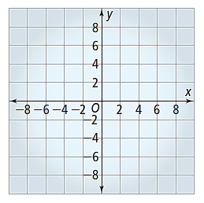
6. [Sketch on coordinate grid provided.] | 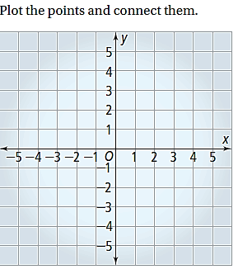

8. [Sketch on coordinate grid provided.]

Find the amount in a continuously compounded account for the given conditions.
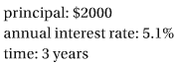 |  | 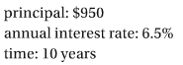
 | 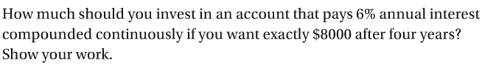
 | 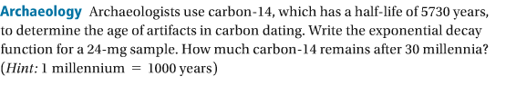
 | 