Get Ready!
UNIT
6
Lesson 5-1 |  | Graphing Quadratic Functions  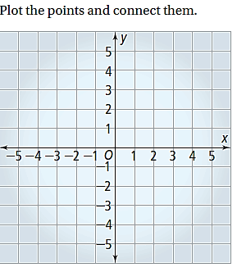  - Graph the function by using a table of values. Indicate the vertex, axis of symmetry, $y$-intercept, and $x$-intercept.  $$y=-\frac{1}{2}x^{2}$$  $$x$$ $$y$$
Lesson 5-2 |  | 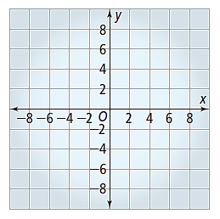  - Graph the function. Indicate the vertex, axis of symmetry, $y$-intercept, and $x$-intercept.  $$y=x^{2}-8x+7$$
Lesson 5-4 |  | - Graph the function. Indicate the vertex, axis of symmetry, $y$-intercept, and $x$-intercept.  $$y={\left(x-3\right)}^{2}-4$$

Lesson 5-5 |  | Writing Equations of Parabolas  Use the given information to write in vertex form the equation of the parabola.  - A parabola with$a=-\frac{1}{3};vertex (4, -1)$.  - A parabola with the standard form equation: $y=5x^{2}+10x+2$  - The parabola drawn on the graph below.  $$(1,2)$$  $$(-1, 0)$$
Lesson 5-3 |  | Solving Quadratic Equations by Factoring  Solve each equation by factoring.  - $x^{2}-x-20=0$  - $x^{2}+6x-27=0$  - $3x^{3}-9x+6=0$

Lesson 5-7 |  | Solving Quadratic Equations using the Quadratic Formula  Solve each equation by using the quadratic formula.  - $x^{2}-12x+30=0$  - $-4x^{2}+20x-25=0$  - $2x^{2}-8x+8=0$

Solve the equation using any method.
- $2x^{2}+14x=-12$

