**Warm-Up**

Function Operations

1. If $g\left(x\right)=4-2x, \text{what is} g(x-4)\text{?}$

$-2x$

$-2x-4$

$-2x+8$

$-2x+12$

$-2x^{2}+12x-16$

**Student-Produced Response: Use the grid to bubble in your answer.**



$\text{If }h\left(x\right)=x^{2}+2x \text{and} j\left(x\right)=\left|\frac{x}{4}+2\right|. \text{What is} j\left(h\left(4\right)\right)?$

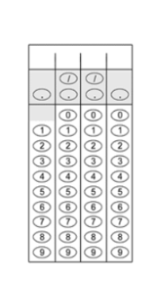

**Critical Thinking**

$\text{For any positive integer} n, \text{let }n^{} \text{be defined by} n^{}=2n\left(n+1\right)\text{. What is the value of} \frac{8^{}}{2^{}}\text{?}$

$2^{}$

$4^{}$

$6^{}$

$8^{}$

${10}^{}$

**Lesson 7-7: Inverses Relations & Functions**

|  |  |
| --- | --- |
| Algebra Objective | Students will be able to find the inverse of a relation or function. |
| Language Objective | C:\Users\Amber\AppData\Local\Microsoft\Windows\Temporary Internet Files\Content.IE5\Y1HPRU6G\MC900357853[1].wmfStudents will sequence inverse operations with a partner. |

**Vocabulary Bites**

* An ________________________ is an operation that undoes another.

Subtraction is the ***inverse*** of ______________

________________ is the ***inverse*** of multiplication.

A square root is the ***inverse*** of a _____________.

The inverse of a function may or may not be a function.

The diagram shows a relation $r$ (a function) and its ***inverse*** (not a function). The *range* of the relation is the *domain* of the ***inverse***. The *domain* of the relation is the *range* of the ***inverse***.

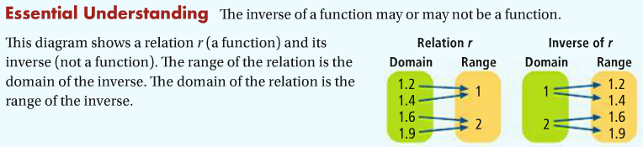

|  |  |  |  |  |  |  |  |
| --- | --- | --- | --- | --- | --- | --- | --- |
| ***One-to-One Function*** | |  | ***Function, but not one-to-one*** | |  | ***Non-function*** | |
| $$x$$ | $$y$$ |  | $$x$$ | $$y$$ |  | $$x$$ | $$y$$ |
| 0 | 2 |  | 0 | 2 |  | 1 | 2 |
| 1 | 3 |  | 1 | 3 |  | 2 | 3 |
| 2 | 4 |  | 2 | 2 |  | 1 | 4 |

* A ***function*** is a relationship in which each *input*____________________________________________ *output*.
* A _________-____- _________ ***function*** is a relationship in which _____________________________ *input* ____________________________________________________________ *output*.
* An ***inverse*** ______________________, represented by $f^{-1}(x)$, undoes (or *reverses*) another function by switching the order of each *input* and *output*, so that each.



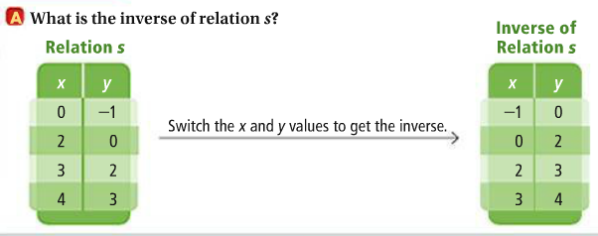



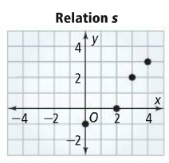





|  |  |
| --- | --- |
|  |  |

**You Try:** 





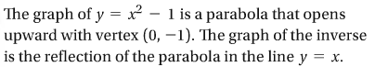



**You Try:**

|  |  |
| --- | --- |
|  |  |







|  |  |
| --- | --- |
|  |  |







**L7-7 CLASSWORK**Inverse Relations & Functions

***Directions*:** Identify the vertex of each function. Find the inverse of the function and the vertex of the inverse.

|  |  |  |  |  |  |  |  |  |  |  |  |  |  |  |  |  |  |  |  |  |  |  |  |  |  |
| --- | --- | --- | --- | --- | --- | --- | --- | --- | --- | --- | --- | --- | --- | --- | --- | --- | --- | --- | --- | --- | --- | --- | --- | --- | --- |
| |  |  |  | | --- | --- | --- | |  | ***Original $f(x)$*** | ***Inverse*** | |  |  |  | |  |  |  | | Vertex: |  |  | | |  |  |  | | --- | --- | --- | |  | ***Original $f(x)$*** | ***Inverse*** | |  |  |  | |  |  |  | | Vertex: |  |  | |
| |  |  |  | | --- | --- | --- | |  | ***Original $f(x)$*** | ***Inverse*** | |  |  |  | |  |  |  | | Vertex: |  |  | | |  |  |  | | --- | --- | --- | |  | ***Original $f(x)$*** | ***Inverse*** | |  |  |  | |  |  |  | | Vertex: |  |  | |
| 1. #TKO  |  |  |  | | --- | --- | --- | |  | ***Original*** | ***Inverse*** | |  |  |  | |  |  |  | | Vertex: |  |  | | 1. #TKO  |  |  |  | | --- | --- | --- | |  | ***Original $f(x)$*** | ***Inverse*** | |  |  |  | |  |  |  | | Vertex: |  |  | |

**L7-7 HOMEWORK**

Inverses Relations & Functions

Vertex Form

$$y=a{\left(x-h\right)}^{2}+k$$

Mixed Review

**Identify the vertex of each function. Convert each to standard form.**

|  |  |
| --- | --- |
| $y={\left(x-3\right)}^{2}+5$ | $y=2{\left(x+1\right)}^{2}-5$ |

Find the inverse of each relation. Graph the given relation and its inverse.

|  |  |  |  |
| --- | --- | --- | --- |
|  |  |  |  |

Find the inverse of each function. Is the inverse a function?

|  |  |
| --- | --- |
| $y=x^{2}+4$ | $y=3x^{2}-5$ |

GO

Find the inverse of each function, then sketch the original function and its inverse.

|  |  |
| --- | --- |
| $y={\left(x-3\right)}^{2}$ | $y={-2x}^{2}-6$ |

For each function, find the inverse and the domain and range of the function and its inverse. Determine whether the inverse is a function.

$f\left(x\right)=\sqrt{x+7}$