L7-3 Homework
Binomial Radical Expressions

Complete #12-39 (multiples of 3).
Simplify is possible.

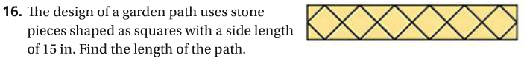

Simplify.

Multiply.

Multiply each pair of conjugates.

Rationalize each denominator. Simplify your answer.
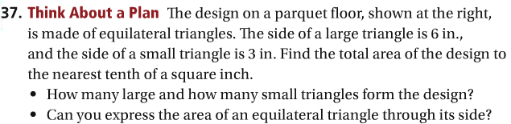

Simplify.

