**Lesson 6-1: Introduction to Polynomial Functions**

|  |  |
| --- | --- |
| Algebra Objective | Students will be able to classify polynomials, to graph polynomial functions, and to describe end behavior. |
| Language Objective | Students will use vocabulary including monomial, degree, polynomial, turning point, and end behavior. |

Big Idea

Qualities of a polynomial ***function*** (or equation) tell you about the way its ***graph*** will look.

|  |  |  |
| --- | --- | --- |
| **Function** | **C:\Users\ajackson\AppData\Local\Microsoft\Windows\Temporary Internet Files\Content.IE5\EHCYB2OC\arrow-orange-right-6041-large[1].png** | **Graph** |
|  |  |  |
|  |  |  |

**C:\Users\Amber\AppData\Local\Microsoft\Windows\Temporary Internet Files\Content.IE5\Y1HPRU6G\MC900357853[1].wmfVocabulary Bites**

$$P\left(x\right)=4x^{3}+3x^{2}+5x-2$$

|  |  |  |  |
| --- | --- | --- | --- |
|  |  |  |  |

* A polynomial with one term is called a ________________.
* An expression with any number of terms is called a ____________________.
* When terms are written in decreasing order of power of variable, we say the polynomial is written in ________________ ________.

**Classifying Polynomials**

|  |  |  |  |  |
| --- | --- | --- | --- | --- |
| **Degree** | **Name Using Degree** | **Polynomial Example** | **Number of Terms** | **Name Using Number of Terms** |

|  |  |  |  |  |
| --- | --- | --- | --- | --- |
|  |  |  |  |  |
|  |  |  |  |  |
|  |  |  |  |  |
|  |  |  |  |  |
|  |  |  |  |  |
|  |  |  |  |  |

**Polynomial Functions**

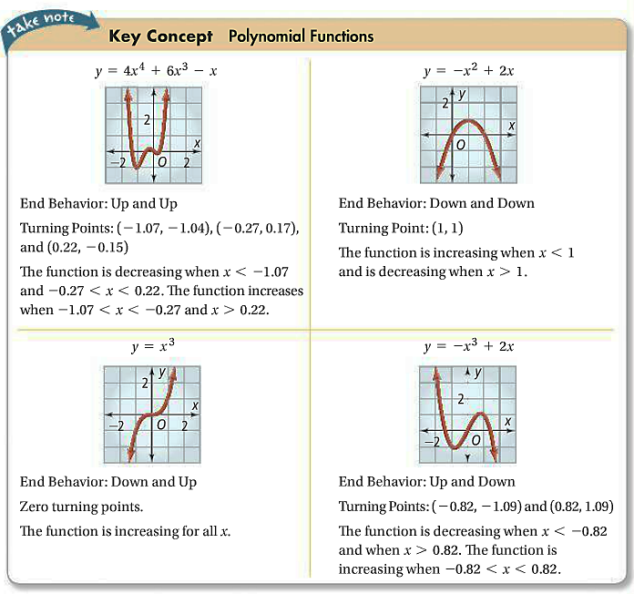

**End Behavior**

|  |  |  |
| --- | --- | --- |
|  | $$n is even n≠0$$ | $$n is odd$$ |
| $a$*positive* |  |  |
| $a$*negative* |  |  |

**Graphing Cubic Functions**

**What is the graph of each cubic function? Describe the graph, including end behavior, turning points, and increasing/decreasing intervals.**

|  |  |  |  |  |  |  |  |  |  |  |  |  |
| --- | --- | --- | --- | --- | --- | --- | --- | --- | --- | --- | --- | --- |
| A     |  |  | | --- | --- | |  |  | |  |  | |  |  | |  |  | |  |  | |  |  | |
| B     |  |  | | --- | --- | |  |  | |  |  | |  |  | |  |  | |  |  | |  |  | |

**L6-1 Homework**

Introduction to Polynomial Functions

**Complete #9-36 [Multiples of 3].**

***Write each polynomial in standard form. Then classify it by degree by number of terms.***

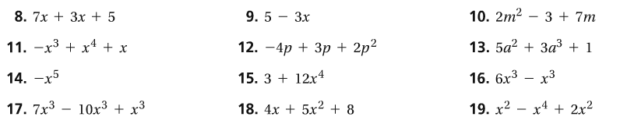

***Determine the end behavior of the graph of each polynomial function.***

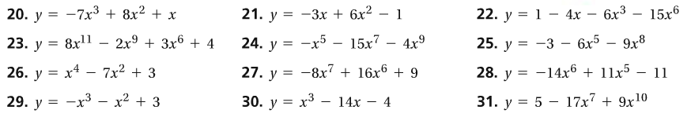

***Describe the shape of the graph of each cubic function including end behavior, turning points, and increasing/decreasing intervals.***

